Understanding Ridge Regression in Statistical Analysis

[[Everton Gomede, PhD](https://medium.com/@evertongomede?source=post_page-----de42947ed18b--------------------------------)](https://medium.com/@evertongomede?source=post_page-----de42947ed18b--------------------------------)

[[The Modern Scientist](https://medium.com/the-modern-scientist?source=post_page-----de42947ed18b--------------------------------)](https://medium.com/the-modern-scientist?source=post_page-----de42947ed18b--------------------------------)

[Everton Gomede, PhD](https://medium.com/@evertongomede?source=post_page-----de42947ed18b--------------------------------)

·

[Follow](https://medium.com/m/signin?actionUrl=https%3A%2F%2Fmedium.com%2F_%2Fsubscribe%2Fuser%2Fb1a64eb107f0&operation=register&redirect=https%3A%2F%2Fmedium.com%2Fthe-modern-scientist%2Funderstanding-ridge-regression-in-statistical-analysis-de42947ed18b&user=Everton+Gomede%2C+PhD&userId=b1a64eb107f0&source=post_page-b1a64eb107f0----de42947ed18b---------------------post_header-----------)

Published in

[The Modern Scientist](https://medium.com/the-modern-scientist?source=post_page-----de42947ed18b--------------------------------)

·

4 min read

·

Jan 3

93

**Introduction**

In the world of statistical modeling and machine learning, regression analysis is a fundamental tool used to understand relationships between variables. Among the various types of regression techniques, Ridge Regression stands out as a particularly useful method, especially when dealing with multicollinearity and overfitting. This essay delves into the concept of Ridge Regression, its mathematical foundation, applications, advantages, and limitations.



*In the realm of data, as in life, the path of least resistance often leads to overcrowded roads. Ridge Regression, like a wise guide, takes us on a less traveled route, where the journey might be slightly more complex, but the destination is reached with greater accuracy and reliability.*

**Background**

Ridge Regression, also known as Tikhonov regularization, is a technique used to analyze multiple regression data that suffer from multicollinearity. Multicollinearity occurs when independent variables in a regression model are highly correlated. This condition can lead to unreliable and unstable estimates of regression coefficients in ordinary least squares (OLS) regression. Ridge Regression addresses this issue by introducing a penalty term to the regression model.

**Mathematical Foundation**

The fundamental idea behind Ridge Regression is to add a penalty (the ridge penalty) to the sum of squares of the coefficients in the regression model. The ridge penalty is the square of the magnitude of the coefficients multiplied by a parameter known as lambda (λ), which controls the strength of the penalty.

The Ridge Regression model is represented as:

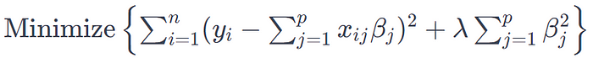

where *yi*​ is the dependent variable, *xij*​ are the independent variables, *βj*​ are the coefficients, and *n* and *p* represent the number of observations and predictors, respectively.

**Applications and Advantages**

Ridge Regression is widely used in situations where OLS regression fails to provide reliable estimates:

1. **Handling Multicollinearity**: By adding a penalty to the coefficients, Ridge Regression reduces the problem of multicollinearity, leading to more reliable estimates.
2. **Preventing Overfitting**: The technique is useful in preventing overfitting in the model, particularly in scenarios where the number of predictors is large relative to the number of observations.
3. **Improving Prediction Accuracy**: Ridge Regression can lead to an improvement in the prediction accuracy due to the bias-variance trade-off.

**Limitations**

Despite its advantages, Ridge Regression has limitations:

1. **Choice of Lambda**: Selecting an appropriate value for the lambda parameter is crucial. Cross-validation is typically used, but it can be computationally intensive.
2. **Biased Estimators**: The method introduces bias into the estimates of the regression coefficients. However, this is a trade-off for lower variance and better prediction accuracy.
3. **Inapplicability for Feature Selection:** Ridge Regression does not perform feature selection; it only shrinks the coefficients towards zero but never exactly to zero.

**Code**

To demonstrate Ridge Regression in Python, we’ll follow these steps:

1. Create a synthetic dataset.
2. Split the dataset into training and testing sets.
3. Apply Ridge Regression to the dataset.
4. Evaluate the model’s performance.
5. Plot the results.

Here’s a complete Python code example to illustrate this process:

import numpy as np  
import matplotlib.pyplot as plt  
from sklearn.model_selection import train_test_split  
from sklearn.linear_model import Ridge  
from sklearn.metrics import mean_squared_error  
from sklearn.datasets import make_regression  
  
# Step 1: Create a synthetic dataset  
X, y = make_regression(n_samples=100, n_features=1, noise=10, random_state=42)  
  
# Step 2: Split the dataset into training and testing sets  
X_train, X_test, y_train, y_test = train_test_split(X, y, test_size=0.2, random_state=42)  
  
# Step 3: Apply Ridge Regression to the dataset  
# Note: Adjust alpha to see different results (alpha is the λ in Ridge formula)  
ridge_model = Ridge(alpha=1.0)  
ridge_model.fit(X_train, y_train)  
  
# Predictions  
y_train_pred = ridge_model.predict(X_train)  
y_test_pred = ridge_model.predict(X_test)  
  
# Step 4: Evaluate the model's performance  
train_error = mean_squared_error(y_train, y_train_pred)  
test_error = mean_squared_error(y_test, y_test_pred)  
print(f"Train MSE: {train_error}, Test MSE: {test_error}")  
  
# Step 5: Plot the results  
plt.scatter(X_train, y_train, color='blue', label='Training data')  
plt.scatter(X_test, y_test, color='red', label='Testing data')  
plt.plot(X_train, y_train_pred, color='green', label='Ridge model')  
plt.title("Ridge Regression with Synthetic Dataset")  
plt.xlabel("Feature")  
plt.ylabel("Target")  
plt.legend()  
plt.show()

Train MSE: 73.28536502082304, Test MSE: 105.78604284136125

To run this code:

1. Ensure you have Python installed with the necessary libraries: NumPy, Matplotlib, and scikit-learn.
2. You can adjust the alpha parameter in the Ridge function to see how different values affect the model. The alpha parameter in the code corresponds to the λ (lambda) in the Ridge Regression formula.
3. The synthetic dataset is generated using scikit-learn’s make_regression function, which creates a dataset suitable for regression.

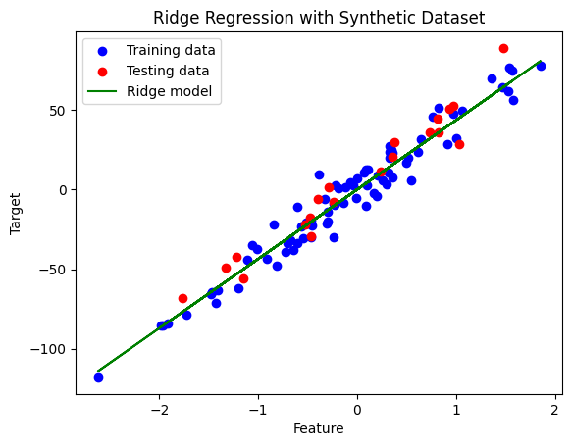

This code will create a Ridge Regression model, apply it to a synthetic dataset, evaluate its performance using Mean Squared Error (MSE), and display a plot showing the fit of the Ridge Regression model to the training and testing data.

**Conclusion**

Ridge Regression is a powerful statistical tool for dealing with some of the inherent problems in regression analysis, such as multicollinearity and overfitting. By incorporating a penalty term, it provides a robust alternative to ordinary least squares regression, especially in complex datasets with many predictors. While it introduces some bias into the model, this is often a worthwhile trade-off for the gains in stability and prediction accuracy. However, practitioners must be mindful of its limitations, including the challenges in selecting the appropriate lambda value and its inability to perform feature selection. Overall, Ridge Regression is an indispensable technique in the arsenal of statisticians, data analysts, and machine learning practitioners.